Lab Report 3

*Name: Sricharan Vinoth Kumar*

*Roll no: 2024112022*

*Group no: 10*

Experiment 1:

* Objective:

To assemble a binary Half Adder.

* Electronic Components Used:
  + Digital Test Kit
  + 7408 2 input AND IC
  + 7486 2 input XOR IC
* Reference Circuit:

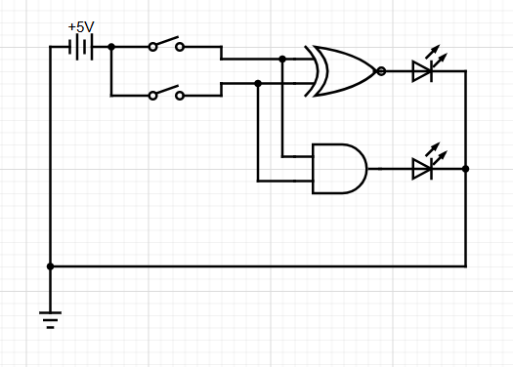

* Procedure:
  1. Ensure that the input pins IP1-12 and output LEDs LG1-12 and LR1-12 are working. Set the CLOCK of the kit in FAST mode.
  2. Set up the Half Adder as per the given circuit diagram using the AND and XOR ICs.
  3. Connect any of the 2 input pins IP1-12 to the Half Adder and observe the outputs for the different combinations of inputs and draw the truth table accordingly.
  4. Verify whether the truth table is correct or not.
* Observation:

Truth Table Obtained:

|  |  |  |  |
| --- | --- | --- | --- |
| A | B | S | C |
| 0 | 0 | 0 | 0 |
| 0 | 1 | 1 | 0 |
| 1 | 0 | 1 | 0 |
| 1 | 1 | 0 | 1 |

* Conclusion:

The Half Adder has been assembled successfully.

* TinkerCAD simulation:

<https://www.tinkercad.com/things/2Z5f7NjTYS8-dsm-lab-3-exp-1?sharecode=tDout30IiVALsIo0KvfZ7QDe-Vk6hJEkwAsa4p3Seng>

Experiment 2:

* Objective:

To assemble a binary Full Adder.

* Electronic Components Used:
  + Digital Test Kit
  + 7408 2 input AND IC
  + 7486 2 input XOR IC
  + 7432 2 input OR IC
* Reference Circuit:

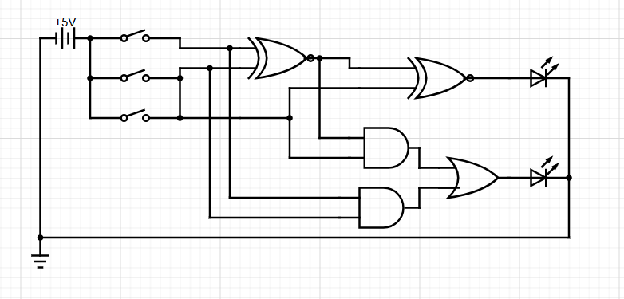

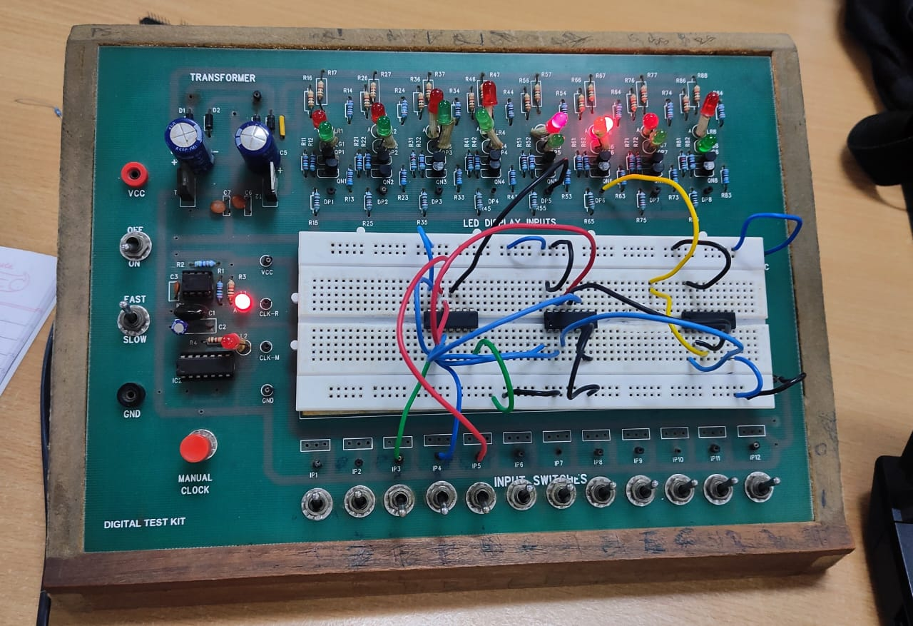

* Procedure:
  1. Ensure that the input pins IP1-12 and output LEDs LG1-12 and LR1-12 are working. Set the CLOCK of the kit in FAST mode.
  2. Set up an Half Adder as done in the previous experiment.
  3. Connect output C and the output of the Half Adder S1 and inputs to a new Half Adder to generate outputs S2 and C2.
  4. Generate the final CARRY by connecting C1 and C2 to an OR gate.
  5. Generate the truth table using the inputs A, B, C and outputs S2 and CARRY.
  6. Verify whether the truth table is correct or not.
* Observation:

Truth table obtained:

|  |  |  |  |  |
| --- | --- | --- | --- | --- |
| A | B | C | S2 | CARRY |
| 0 | 0 | 0 | 0 | 0 |
| 0 | 0 | 1 | 1 | 0 |
| 0 | 1 | 0 | 1 | 0 |
| 0 | 1 | 1 | 0 | 1 |
| 1 | 0 | 0 | 1 | 0 |
| 1 | 0 | 1 | 0 | 1 |
| 1 | 1 | 0 | 0 | 1 |
| 1 | 1 | 1 | 1 | 1 |

* Conclusion:

The Full Adder has been assembled successfully.

* TinkerCAD Simulation:

<https://www.tinkercad.com/things/a8eLwplTqy6-dsm-lab-3-exp-2?sharecode=CVRFh-eGHBVCAhqUD_OsvlXmlKjn7ORH-jJFyHKRVrM>

Experiment 3:

* Objective:

To build a binary Half Subtractor.

* Electronic Components Used:
  + Digital Test Kit
  + 7408 2 input AND IC
  + 7486 2 input XOR IC
  + 7040 Hex Inverter NOT IC
* Reference Circuit:

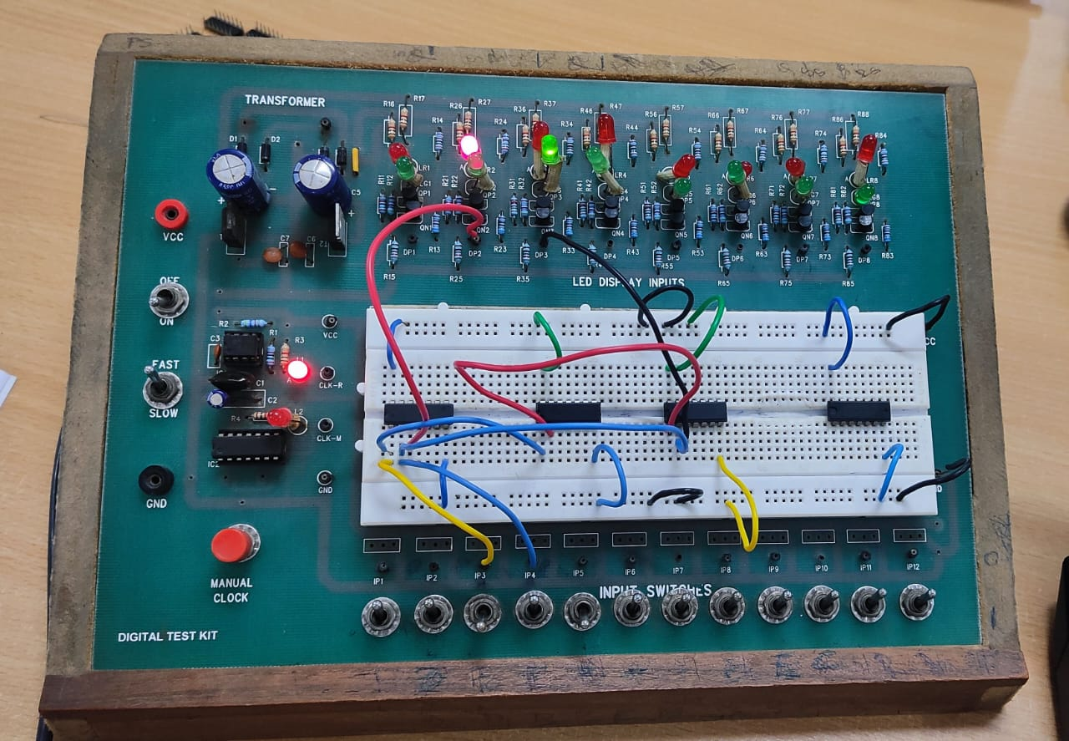

* Procedure:
  1. Ensure that the input pins IP1-12 and output LEDs LG1-12 and LR1-12 are working. Set the CLOCK of the kit in FAST mode.
  2. Set up the Half Subtractor as per the given circuit diagram using the AND, NOT and XOR ICs.
  3. Connect any of the 2 input pins IP1-12 to the Half Subtractor and observe the outputs for the different combinations of inputs and draw the truth table accordingly.
  4. Verify whether the truth table is correct or not.
* Observation:

Truth table obtained:

|  |  |  |  |
| --- | --- | --- | --- |
| A | B | S | Borrow |
| 0 | 0 | 0 | 0 |
| 0 | 1 | 1 | 1 |
| 1 | 0 | 1 | 0 |
| 1 | 1 | 0 | 0 |

* Conclusion:

The Half Subtractor has been assembled successfully.

* TinkerCAD Simulation:

<https://www.tinkercad.com/things/9E9Jzk68uW1-dsm-lab-3-exp-3?sharecode=aRmPqEZrio4ENFEz_2yLCqer2BsTBs8Lw75y9emcvqA>

Experiment 4:

* Objective:

To build a binary Full Subtractor.

* Electronic Components Used:
  + 7408 2 input AND IC
  + 7486 2 input XOR IC
  + 7404 Hex Inverter (NOT) IC
  + 7432 2 input OR IC
* Reference Circuit:

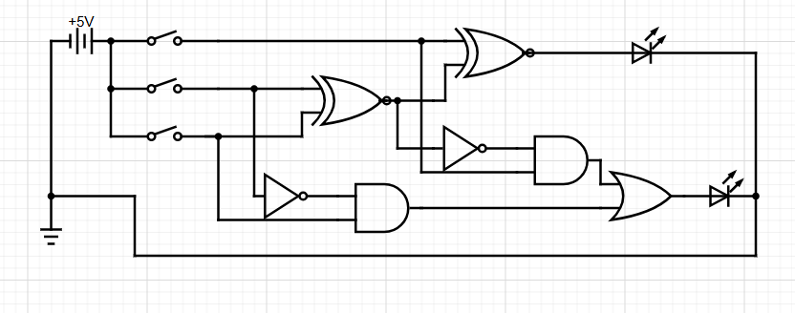

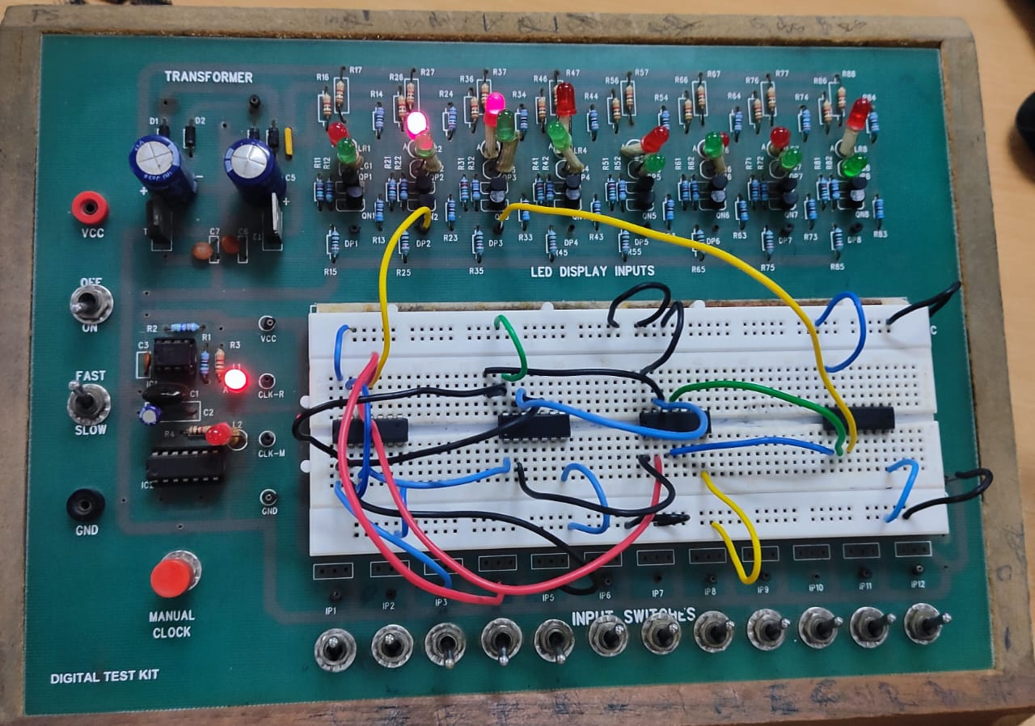

* Procedure:
  1. Ensure that the input pins IP1-12 and output LEDs LG1-12 and LR1-12 are working. Set the CLOCK of the kit in FAST mode.
  2. Set up the Half Subtractor as done in the previous experiment.
  3. Connect output C and the output of the Half Subtractor D1 to a new Half Subtractor to generate the final output D2 and borrow B2.
  4. Connect the borrows B1 and B2 to an OR gate to get the final BORROW.
  5. Obtain the truth table of the inputs A,B,C and the outputs D2 and BORROW.
  6. Verify whether the truth table is correct or not.
* Observation:

Truth table obtained:

|  |  |  |  |  |
| --- | --- | --- | --- | --- |
| A | B | C | D2 | BORROW |
| 0 | 0 | 0 | 0 | 0 |
| 0 | 0 | 1 | 1 | 1 |
| 0 | 1 | 0 | 1 | 1 |
| 0 | 1 | 1 | 0 | 1 |
| 1 | 0 | 0 | 1 | 0 |
| 1 | 0 | 1 | 0 | 0 |
| 1 | 1 | 0 | 0 | 0 |
| 1 | 1 | 1 | 1 | 1 |

* Conclusion:

The Full Subtractor has been assembled successfully.

* TinkerCAD Simulation:

<https://www.tinkercad.com/things/3NQhxHejLCC-dsm-lab-3-exp-4?sharecode=toktUGxAeWzVLtSaOXq_9II3G1w0EZMv0DAHHEYnq08>